Multiple-choice section – choose the correct answer

Question 1 [2.6] [10A]

A sample of test scores from classes 10A and 10B are shown below. The differences between the means and the interquartile ranges, respectively, from the data sets are:

10A: 56, 78, 98, 78, 88, 67, 88, 83, 67, 55

10B: 66, 58, 72, 80, 60, 97, 58, 80, 50, 52

A 9.5, 15 B 9.5, 1 C 8.5, 15 D 8.5, 1

Question 2 [2.3]

The following graph shows the temperature as recorded every hour for 9 hours from noon.

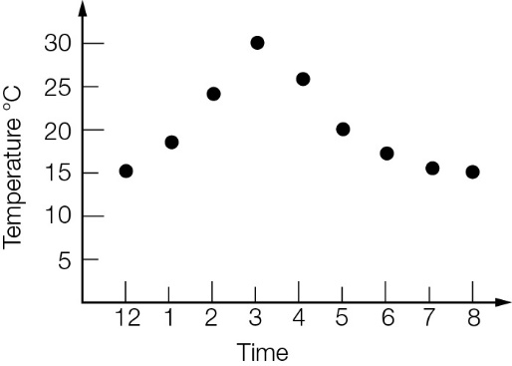

Which of the following statements is incorrect?

A The minimum temperature recorded was 15 °C.

B The maximum temperature recorded was 30 °C.

C The maximum temperature reached on the day was 30 °C.

D The temperature rose quicker in the early afternoon than it fell in the late afternoon/evening.

Question 3 [2.5]

Which box plot represents the following data set?

1, 1, 2, 2, 3, 4, 5, 5, 6

|  |  |
| --- | --- |
| A  PM10_PR_TSa_7_02 | B  PM10_PR_TSa_7_03 |
| C  PM10_PR_TSa_7_04 | D  PM10_PR_TSa_7_05 |

Question 4 [2.2]

If a data set has a lower quartile value of 17 and upper quartile of 25, then:

A a value of 6 would be considered an outlier

B values of 6 and 36 are both outliers

C a value of 36 would be an outlier

D neither 6 nor 36 would be outliers.

Question 5 [2.2]

For the data set represented in the cumulative frequency graph, 60% of the data is below which approximate value?

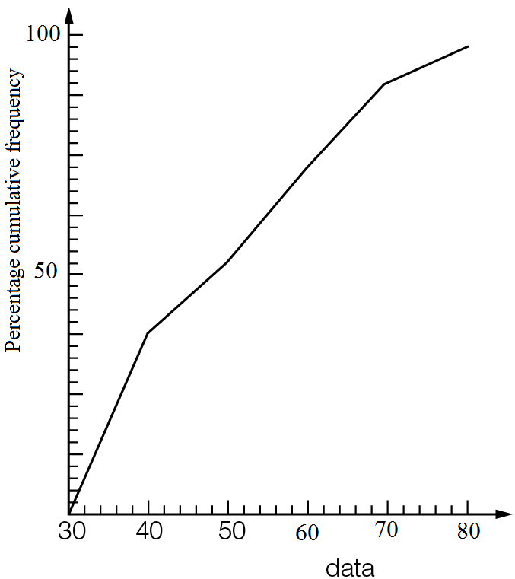

A 39 B 54 C 65 D 72

Question 6 [2.1]

The interquartile range for the data set is:

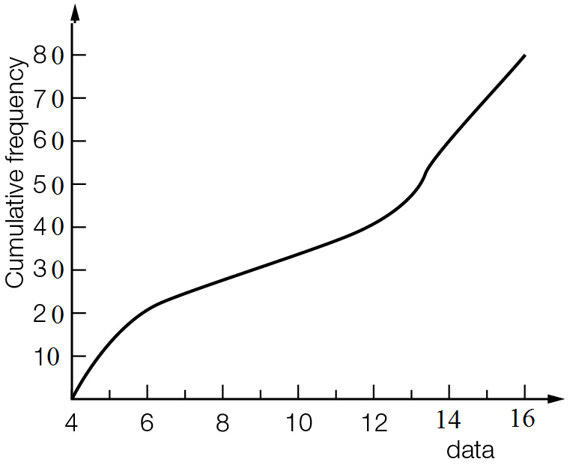

A 4 B 6 C 8 D 10

Question 7 [2.2]

The five-number summary (minimum value, lower quartile, median, upper quartile, maximum value) of a particular data set are related as follows:

* the interquartile range is 15
* the median and 25th percentile are both 45
* the range of the data is 55

The data set is:

A 5, 45, 45, 60, 65 B 15, 45, 45, 45, 70 C 15, 45, 45, 60, 70 D 10, 30, 45, 50, 65

Question 8 [2.2]

The mean and standard deviation, respectively, for the data set correct to 1 decimal place is:

1.7, 3.3, 2.3, 0.6, 8.8

A 3.3, 3.2 B 3.4, 3.2 C 3.3, 2.9 D 3.4, 2.9

Question 9 [2.8] [10A]

The coordinate point that could belong to the line of best fit joining the points below is:

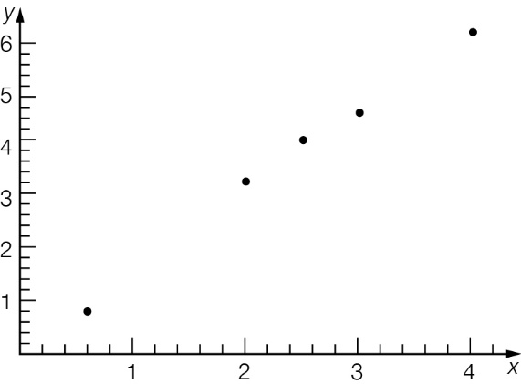

A (1, 0.8) B (2, 3.8) C (3.5, 5.2) D (2, 2)

Multiple-choice results: \_\_\_ / 9

Short answer section

Question 10 2 marks [2.1–2.7]

Choose from the following words and expressions to complete the sentences below.

box plot outlier percentile quartile scatter plot cumulative frequency

(a) A \_\_\_\_\_\_\_\_\_\_\_\_\_\_\_\_\_\_\_\_\_\_\_\_\_ curve can be used to find the five-number summary from a set of continuous data that is presented in grouped form.

(b) An \_\_\_\_\_\_\_\_\_\_\_\_\_ is a value that is significantly lower or higher than the majority of values in a data set.

Question 11 5 marks [2.1]

(a) Write a data set with at least 15 whole number values. The data set should have a lowest value of 5, a highest value of 16, a lower quartile of 7.5, an upper quartile of 15 and a median of 10.5.

(b) Calculate the mean of your set of data correct to 1 decimal place.

Question 12 7 marks [2.1]

|  |  |
| --- | --- |
| x | f |
| 23 | 8 |
| 24 | 10 |
| 25 | 3 |
| 26 | 4 |
| 27 | 1 |

(a) Calculate the mean of the data correct to 1 decimal place.

(b) Calculate the median and quartiles of the data. Write the five-number summary.

Question 13 3 marks [2.2]

Construct a box plot from the cumulative frequency curve of 24 data. Use the horizontal axis  
for the box plot.

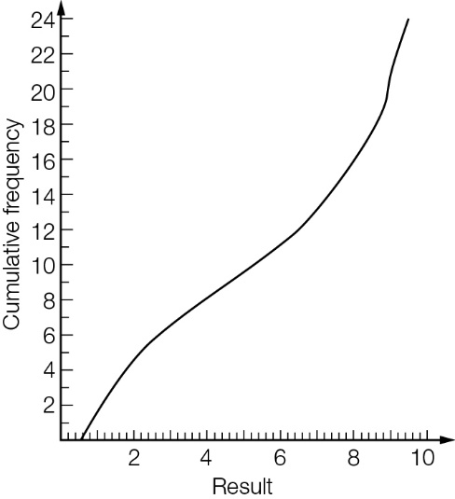

Question 14 5 marks [2.3]

(a) For each data set find the (i) median (ii) range and (iii) interquartile range.

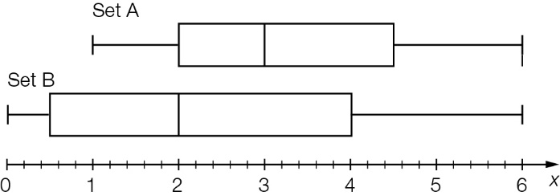

(b) Compare the statistics for the two data sets.

Question 15 3 marks [2.2]

Would any of the following values be considered to be an outlier?

Give reasons for your answers and show full working.

15.2, 12.5, 14.1, 2.9, 13.7, 25.2, 11.6, 12.8

Question 16 4 marks [2.4]

Plot the following points on the axes below and describe the relationship between x and y:

(1.8, 3.2), (0.7, 1.8), (2.5, 0.5), (0.4, 1.2), (5.4, 2.8), (6, 3.4), (7, 0), (8, 1), (4, 0), (3.5, 3)

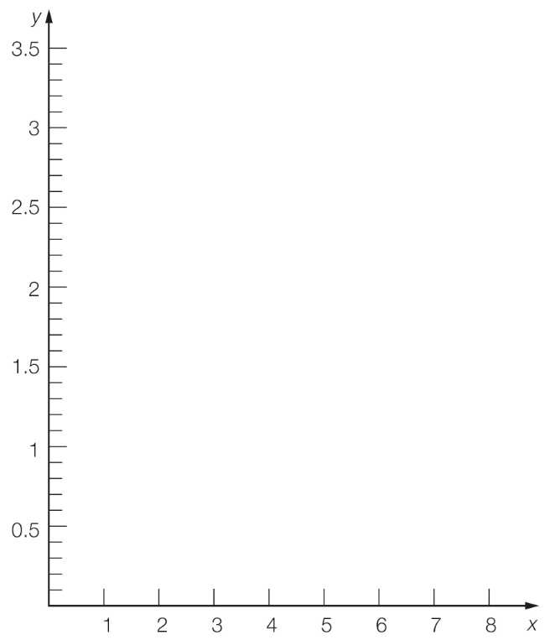

Question 17 3 marks [2.5]

The share price for a volatile stock was recorded each hour for a 5 hour period.

|  |  |  |  |  |  |  |
| --- | --- | --- | --- | --- | --- | --- |
| Time | 1 pm | 2 pm | 3 pm | 4 pm | 5 pm | 6 pm |
| Price | $1 | $2 | $2.50 | $1.30 | $1 | $0.80 |

(a) Draw a scatter plot of the price of the stock on the graph below.

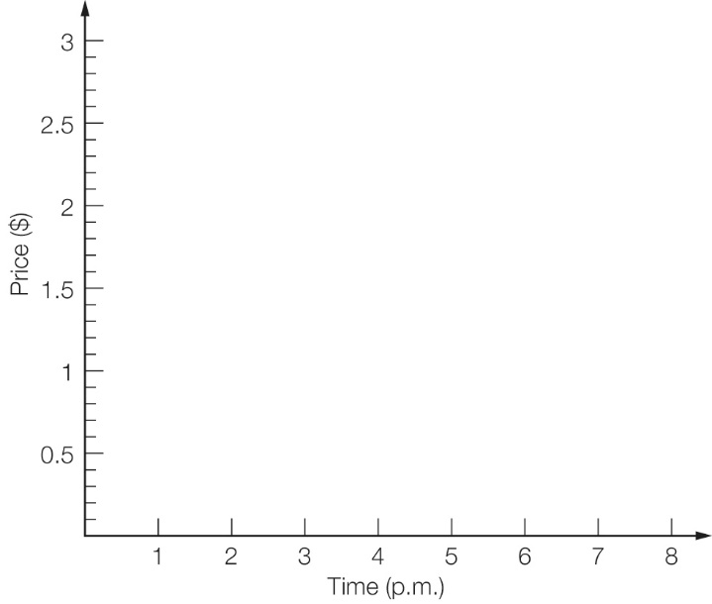

(b) Describe the price movement of the stock over the 5 hour time period.

Question 18 9 marks [2.2]

The following data are the years of death of 26 people buried in a section of a cemetery.

1955, 1944, 1934, 1908, 1955, 1866, 1934, 1945, 1945, 1961, 1944, 1947, 1956,  
1866, 1866, 1954, 1954, 1974, 1942, 1938, 1931, 1950, 1963, 1968, 1953, 1963

(a) Find the mean and median of the data. Write the mean in whole years.

(b) Between which years did the middle 50% of deaths occur?

(c) Identify the outliers in the list.

(d) If the outliers were replaced by the data value nearest to them, what is the effect on the mean and median?

Question 19 4 marks [2.3]

Given that there are 200 data values in the set, construct a cumulative frequency graph from  
the box plot below.

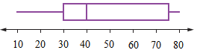

Question 20 5 marks [2.7]

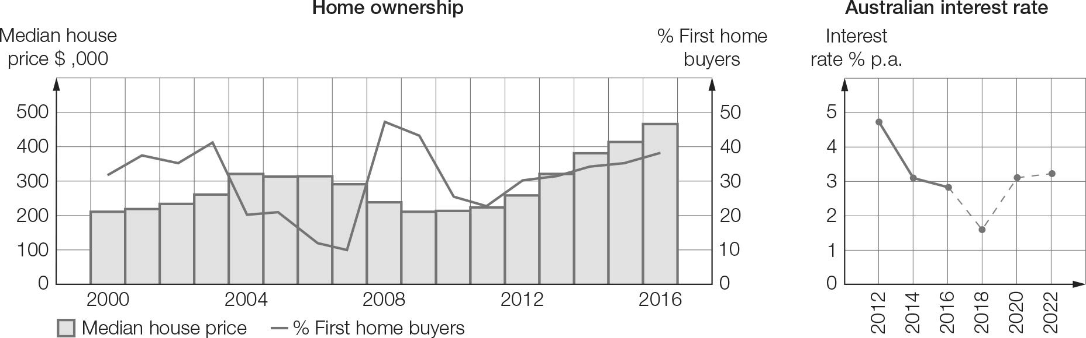

(a) From the graph, estimate the median house price in 2016.

(b) Why does the line graph ‘Australian interest rate’ change to dashed lines after 2016?

(c) During the global financial crisis, the Australian government doubled the value of the first home buyers grant to $14 000 to purchase a house and $21 000 to build, which resulted in a surge of first home buyers entering the real estate market. Based on the graph, in which year do you think the grant was increased?

(d) Why is the time scale different on the two graphs?

(e) Considering the interest rates graph, why might investing in a first home be considered a good idea in 2016?

Short answer results: \_\_\_ / 50

Extended answer section

Question 21 10 marks [2.1]

The frequency table below shows the weights (kg) of players in a cricket club.

|  |  |
| --- | --- |
| Weight (kg) | Frequency |
| 64−<66 | 2 |
| 66−<68 | 4 |
| 68−<70 | 12 |
| 70−<72 | 15 |
| 72−<74 | 11 |
| 74−<76 | 10 |
| 76−<78 | 9 |
| 78−<80 | 7 |

(a) Construct a cumulative frequency curve on the axes provided.

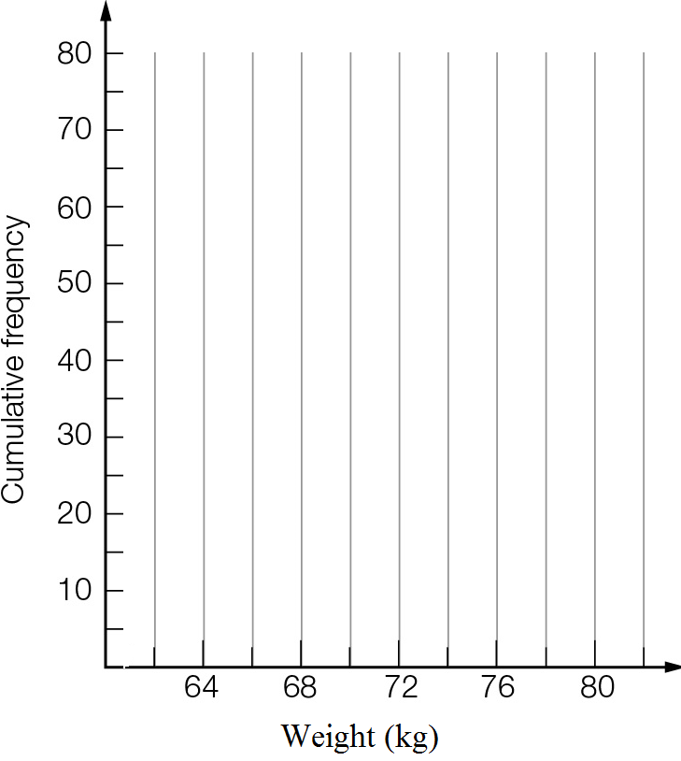

(b) Use the cumulative frequency curve to estimate the lower quartile, median and upper quartile.

(c) Complete the five-number summary and draw a box plot for the data.

|  |  |  |  |  |
| --- | --- | --- | --- | --- |
| Min | QL | Median | QU | Max |
|  |  |  |  |  |

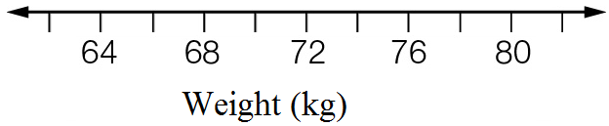

(d) Comment on the accuracy of each of the summary values.

Question 22 10 marks [2.4, 2.6] [10A]

Below are the marks for Maths and English tests.

|  |  |  |  |  |  |  |  |  |
| --- | --- | --- | --- | --- | --- | --- | --- | --- |
| English | 45 | 46 | 30 | 34 | 50 | 44 | 38 | 40 |
| Maths | 27 | 50 | 22 | 28 | 44 | 12 | 44 | 42 |

(a) Considering ‘English mark’ as the independent variable:

(i) Use technology to find a relationship between the marks in the form y = mx + b. Round the values of m and b correct to 2 decimal places.

(ii) Sketch the calculator-drawn graph of the data.

(iii) Write the relationship using the variables ‘Maths mark’ and ‘English mark’.

(iv) Use the relationship to estimate the Maths mark for a student who scored 36 for English.

(v) Which Maths mark is most different from the values estimated by the formula?

(b) Considering ‘Maths mark’ as the independent variable:

(i) Use a calculator to find a relationship between the marks in the form y = mx + b. Round the values of m and b correct to 2 decimal places.

(ii) Write the relationship using the variables ‘English mark’ and ‘Maths mark’.

(iii) Use the relationship to estimate the English mark for a student who got 40 for Maths.

Question 23 15 marks [2.1, 2.3, 2.8]

The data below gives the average monthly minimum daily temperatures (in °C) of two Australian cities. The months are in order from January to December.

City X: 15.5, 15.7, 14.3, 11.6, 9.4, 7.4, 6.8, 7.5, 8.6, 10.4, 12.3, 14.3

City Y: 21.2, 20.6, 17.4, 12.5, 8.2, 5.1, 4, 5.9, 9.7, 14.8, 17.9, 20.2

(a) Find the five-number summary of temperatures for each city.

(b) Draw a parallel box plot for the two cities.



(c) Use the median, range and IQR to compare the temperatures for the two cities.

[10A] (d) Find mean and standard deviation of temperatures for the two cities.

[10A] (e) Use the mean and standard deviation values to compare the temperatures for the two cities.

Question 24 7 marks [2.1, 2.3]

The following table lists the number of games won in the winter season of 10 games by the winning sports teams in a school.

|  |  |
| --- | --- |
| Games won | Number of teams |
| 1 | 2 |
| 2 | 3 |
| 3 | 5 |
| 4 | 1 |
| 5 | 2 |
| 6 | 0 |
| 7 | 1 |
| 8 | 2 |
| 9 | 1 |
| 10 | 3 |

(a) What is the mean number of games won by these winning teams?

(b) What proportion of the winning teams won more than half of their games?

(c) The school had 24 teams playing winter sports. Calculate the mean number of wins for all teams.

(d) What proportion of all teams won more than half of their games?

Question 25 18 marks [2.3, 2.8]

The data below gives the weights of newly hatched chicks in grams.

49 45 40 54 43 56 45 41 49 45 38 45 42 47 52 55 52 33 37 43

40 33 37 43 54 50 38 52 48 45 48 39 38 39 55 42 51 45 41 49

(a) Draw a histogram of the weights. Use a class interval of 5, with the first interval 30–<35.

(b) Construct a box plot for the weights.

(c) Draw a dot plot of the weights.

(d) What do the displays in (a) to (c) tell you about the weights of the chicks?

[10A] (e) Find the mean and standard deviation of the weights, correct to 1 decimal place.

[10A] (f) Treating the 40 data as the population, use the random numbers below to create six samples of size five from the data.  
 14 24 9 11 28 27 28 39 18 15 4 16 15 24 6  
 30 18 9 40 21 2 19 33 4 11 27 24 40 26 11

[10A] (g) Find the sample means and standard deviations.

[10A] (h) Use dot plots to display the distribution of sample statistics about the population statistics.

Extended answer results: \_\_\_ / 60

TOTAL test results: \_\_\_ / 119